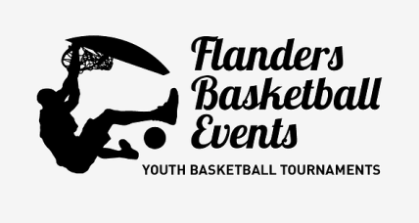

***Flanders Classic Cup 2025  
Torhout (Bruges region) 23 and 24 august  
Tournament for U12/ U14 mixte, U16 boys***

[***www.flabasevents.com***](http://www.flabasevents.com)[***flabasevents@gmail.com***](mailto:flabasevents@gmail.com) ***(0032)(0)473373966***

The 10th edition of this classic tournament will take place again this year in the Bruges region. This two-day tournament is therefore the ideal preparation for the new season for these youth categories and of course also a fantastic team building for your team. Play matches against teams from Flanders, Wallonia, the Netherlands and possibly from other countries.

A digital tournament booklet will also be made in advance with an introduction of all teams. Match results, rankings and next rounds will be continuously visible on a handy app. that can be consulted anywhere, so that you are always kept informed of the state of affairs, both in your accommodation and anywhere during excursions.

Depending on the available time and the interest of the teams, additional events can be organized such as three point contest or All Star Games

Participation:

To participate in the tournament, a Players Pass must be purchased for each player. This Players Pass entitles you to the following:

- an original tournament T-shirt

- a medal

- a beautiful trophy for the team

This Players Pass costs 27.50 euros per player including T-shirt or 20 euros without T-shirt. The 12th pass is always free. There is also a free Coach Pass for the (head) coach. This entitles you to:

- an original tournament T-shirt (if players pay for T-shirt)

- a medal and gift

-New! Earn back your registration fee. If you can convince a self-employed person or company to sponsor your registration fee, we will put this sponsor in the tournament program booklet and on our website for free.

We now also provide the possibility for teams that do not have two days off to register for only 1 day for the time being. If at all possible, we will then try to fit you into the two-day tournament. You may not be able to choose Saturday or Sunday (you can, however, indicate a preferred day), but the best chance is usually that we can fit you in on Saturday. The price of the Players Pass is then 22.50 euros with and 15 euros per player without a T-shirt.

Accommodation and catering

For teams that want accommodation in the region, there are many possibilities. Torhout is a few kilometers from Bruges and not that far from the coast, so there are plenty of possibilities.

a) You simply arrange everything yourself in advance at the hotel or hostel of your choice. Let us know where and for which days you have booked accommodation.

b) You ask us to inquire at one of the hostels that we propose below this invitation (or others). We will check whether there is room, what the exact prices are, etc. After your approval, we will take an option for your accommodation, an option that you then confirm when you are certain of your participation. You then do the further processing of reservations and payments yourself. Since it is still summer vacation, it is possible that certain hostels will fill up quickly in this tourist region. So don't wait too long.

If you want certain meals during the tournament, please let us know. We may be able to have meals delivered to our sports complex via a caterer or we can recommend certain restaurants and possibly make a reservation according to your wishes.

Please note possible cancellation costs for every effective reservation. There is always a very small possibility that the tournament cannot go ahead due to circumstances beyond our control (e.g. too few registrations for a certain category, etc.). In that case, we as an organization are of course not responsible for the cancellation costs you incur.

**Registration Flanders Classic Cup 23/24 August 2025**

Club: ………………………………………………………………………………………..

Contact person: …………………………………………………………………………….

e-mail address: ……………………………………………………………………………………….

Phone : ……………………………………………………………………………………..

Participates with :

O U12 mixed O 2 days O 1 day

On-site manager + mobile : ……………………………………………………………..

O U14 mixed O 2 days O 1 day

On-site manager + mobile : ……………………………………………………………..

O U16 boys O 2 days O 1 day

On-site manager + mobile : ……………………………………………………………..

**Suggested hostels**

De Loyale Maldegem  
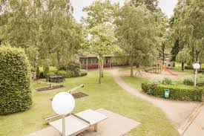 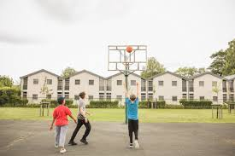

Alle info : <https://www.jeugdherbergen.be/nl/maldegem>

Herdersbrug Dudzele

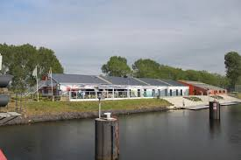 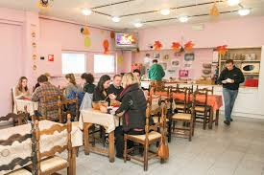

Alle info : <https://www.jeugdherbergen.be/en/brugge-dudzele>

Europa Brugge

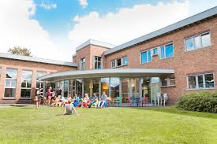 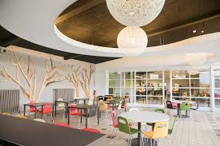

Alle info : <https://www.jeugdherbergen.be/nl/brugge>

De Ploate Oostende (kust)

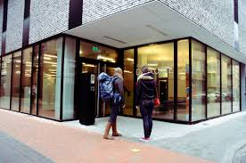 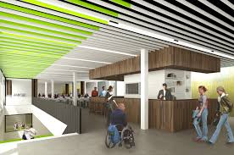

Alle info : <https://www.jeugdherbergen.be/nl/oostende>

Lakeside Paradise Knokke-Heist (kust)

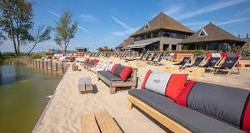 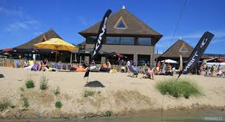

Alle info : <https://www.lakesideparadise.be/>

Ibis Budget Brugge Station

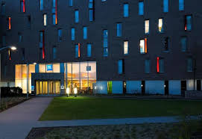

Alle info : <https://all.accor.com/hotel/5046/index.en.shtml>

